**BBC News JS Coding Test**

**Design Phase**

**Gantt Chart**

|  |  |  |  |
| --- | --- | --- | --- |
| Start Date | End Date | Description | Duration (Days) |
| 15/02/2019 | 16/02/2019 | Design: Wireframes; Use Cases; etc | 1 |
| 16/02/2019 | 17/02/2019 | Load articles from JSON | 1 |
| 16/02/2019 | 17/02/2019 | Style article that's loaded in | 1 |
| 17/02/2019 | 18/02/2019 | Switch to the next article | 1 |
| 17/02/2019 | 18/02/2019 | Rank the articles | 1 |
| 18/02/2019 | 19/02/2019 | Bonus: Better CSS | 1 |
| 19/02/2019 | 20/02/2019 | Bonus: Unit tests | 1 |
| 20/02/2019 | 21/02/2019 | Bonus: Preloading articles | 1 |
| 21/02/2019 | 22/02/2019 | Bonus Accessability | 1 |
| 22/02/2019 | 24/02/2019 | Finalise Implementation and ship | 2 |

**Wireframe Diagram(s)**

View Article

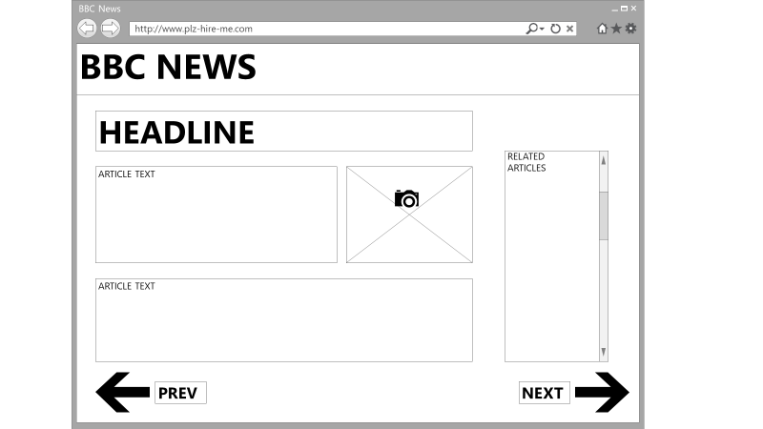

Rate article

